The problem
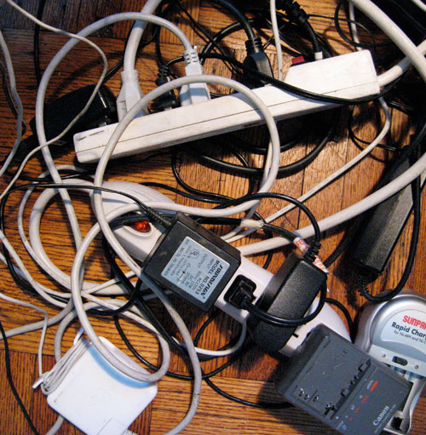
With today’s heavy use of for electrical devices, it is quite common to run short of electrical outlets in the office, home or workshop. Add a power strip to help alleviate the problem, but often people will add a second or even a third strip by plugging it into the original power strip, a practice known as daisy chaining. Unfortunately, daisy chaining can create a potentially serious fire loss due to overloaded electrical circuits.
Every year thousands of fires result from the misuse and overloading of power cords, power strips and surge protectors. The NFPA – National Fire Protection Association reports that wiring, switches and outlets cause an annual average of over $11 M in property damage (NFPA 1999-2002 Study). Unfortunately, poor quality or defective power strips increase the dangers from misuse and overloading.

Power strip basics
A power strip, otherwise know as a relocatable or temporary power tap, is not designed to be used as permanent wiring. When you are not using an electrical device connected to a power strip it is recommended the power strip be unplugged from the outlet, unless the power strip is a UL or ELT listed device and has an internal fuse protector. Temporary wiring is wiring used only for a period of 90 days or less. There is no substitute for permanent wiring.
Power strips offer additional connections apart from the typical wall outlet. Sometimes power strips are daisy chained with other power strips or extended via extension cords. The added length of extension cord wiring can generate excess heat due to an increase in electrical resistance, thereby posing an additional fire risk. Power strips that are not UL or ELT listed devices can be problematic and inferior. Strips that lack internal fuse protection are also suspect.

Solutions to consider
The safest method to supply power for your needs:

- Have a professional install permanent additional wall outlets or other hard wired power drops. During the interim, power taps could be utilized following the guidelines below:

Guidelines for Use of Power Strips

- Use only surge protectors or power strips that are “listed” by UL (Underwriters Laboratory) or ELT (Electrical Testing Laboratories)
- Check to be certain the markings are readily visible on the back of the strip indicating the name of the manufacturer and testing lab used.
- Plug only one strip into single duplex (2 outlet) wall outlet.
- DO NOT DAISY CHAIN - Do not connect one strip to another forming a daisy chain.
- Avoid using an extension cord to reach a remote outlet.
- Visually inspect all power strips regularly to ensure they are not damaged, pinched, crushed or abused in any way.
- Unplug the strip when the appliance powered by the strip is not in use.
- If the power strip becomes hot to the touch – unplug and consult a licensed professional.
- Do not use a power strip that does not have an internal circuit breaker.
- Never use a three to two prong adapter to energize the unit.
- Never cut off the grounding prong of a 3-prong plug.
- Use strips with three –prong grounded plug or one with a polarized plug.
- Equipment with heating elements should not be energized via a power strip such as a hotplate, heat gun, coffee pot or a toaster.

